**Code for Assignment 9 (using Hybrid Inheritance):**

#include<iostream>

using namespace std;

class personal

{

public:

char nm[10];

char dob[10];

};

class academic:virtual public personal

{

public:

char qual[10];

char clgnm[10];

};

class professional:virtual public personal

{

public:

int empid,salary;

char cmpnm[10];

char post[10];

};

class biodata:public academic,public professional

{

public:

void accept();

void display();

};

void biodata::accept()

{

cout<<"\nenter data(nm,dob,qual,clgnm,cmpnm,post,salary,empid)";

cin>>nm>>dob>>qual>>clgnm>>cmpnm>>post>>salary>>empid;

}

void biodata::display()

{

cout<<"\n"<<nm<<"\t"<<dob<<"\t"<<qual<<"\t"<<clgnm<<"\t"<<cmpnm<<"\t"<<post<<"\t"<<salary<<"\t"<<empid;

}

int main()

{

int i,n;

biodata b[10];

cout<<"\nEnter number of records";

cin>>n;

for(i=0;i<n;i++)

{

b[i].accept();

}

cout<<"\nBio Data=";

cout<<"\nName\tDOB\tQual\tClgnm\tCmpnm\tPost\tSalary\tEmpid";

for(i=0;i<n;i++)

{

b[i].display();

}

}

**Output:**

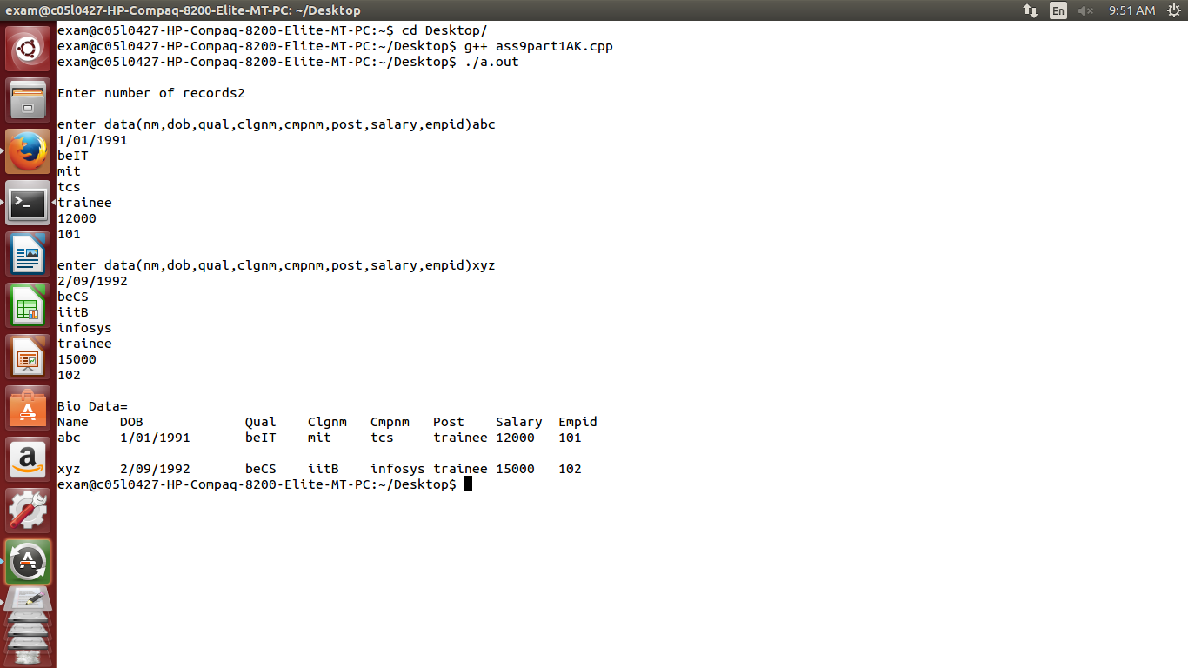

**Code for Assignment 9(using Multiple Inheritance):**

#include<iostream>

using namespace std;

class personal

{

protected:

char name[50];

char address[50];

char birthdate[50];

char gender;

public:

void get_personal();

};

class professional

{

protected:

int noofyearsexp;

char orgname[50];

char projname[50];

char projdetails[50];

public:

void get_professional();

};

class academic

{

protected:

int year;

int marks;

int percentage;

char Class[50];

public:

void get_academic();

};

class biodata: public personal,public academic,public professional

{

public:void display();

};

void personal::get_personal()

{

cout<<"Enter name::";

cin>>name;

cout<<"Enter Address::";

cin>>address;

cout<<"Enter Birthdate(dd/mm/yyyy)::";

cin>>birthdate;

cout<<"Enter gender(M/F)::";

cin>>gender;

}

void professional::get_professional()

{

cout<<"Enter number of years of exp::";

cin>>noofyearsexp;

cout<<"Enter organization name::";

cin>>orgname;

cout<<"Enter project name::";

cin>>projname;

cout<<"Enter project Details::";

cin>>projdetails;

}

void academic::get_academic()

{

cout<<"Enter academic year::";

cin>>year;

cout<<"Enter total marks::";

cin>>marks;

cout<<"Enter percentage::";

cin>>percentage;

cout<<"Enter class::";

cin>>Class;

}

void biodata::display()

{

cout<<"---------------------Employee Biodata--------------"<<endl;

cout<<"-----------------------------------------------------"<<endl;

cout<<"____________________Personal Details__________________________"<<endl;

cout<<"Name::"<<name<<endl;

cout<<"address::"<<address<<endl;

cout<<"birthdate::"<<birthdate<<endl;

cout<<"Gender::"<<gender<<endl;

cout<<"--------------------------------------------------"<<endl;

cout<<"________________Academic Details________________________"<<endl;

cout<<"Academic Year "<<"marks "<<"percentage "<<"class "<<endl;

cout<<year<<"\t\t0"<<marks<<"\t"<<percentage<<"\t"<<Class<<endl;

cout<<"-------------------------------------------------------"<<endl;

cout<<"_______________Professional Details____________________"<<endl;

cout<<"\nOrganization Name::"<<orgname;

cout<<"\nYears of Experince::"<<noofyearsexp;

cout<<"\nProject Done::"<<projname;

cout<<"\nProject Details::"<<projdetails;

}

int main()

{

biodata b;

b.get_personal();

b.get_academic();

b.get_professional();

b.display();

}

**Output:**

